**Data Source:** Office of National Statistics Website ([Births in England and Wales: summary tables - Office for National Statistics (ons.gov.uk)](https://www.ons.gov.uk/peoplepopulationandcommunity/birthsdeathsandmarriages/livebirths/datasets/birthsummarytables))

**Date of data download**: 01 June, 2023

The following notes have been copied from the data source to provide better understanding of the data:

1. The rates for women of all ages, under 20 and 40 and over are based on the female population aged 15 to 44, 15 to 19 and 40 to 44 respectively.
2. **Age-specific fertility rates (ASFRs)**

ASFRs are a measure of fertility specific to the age of the mother and are useful for comparing the reproductive behaviour of women at different ages. They are calculated by dividing the number of live births to mothers of each age group by the number of females in the population of that age and then expressed per 1,000 women in the age group. They can be calculated for single ages, but are usually calculated for five-year age groups in the reproductive age range, from under 20 years up to 40 years and over. They provide the basis for a detailed analysis of fertility levels by age of mother when giving birth. The ASFR based on five-year age groups is given by:

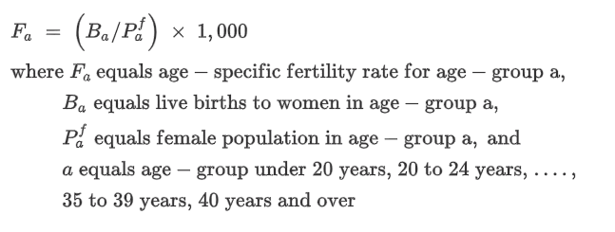

For the groups aged under 20 years and 40 years and over, the female populations used are women aged 15 to 19 years and women aged 40 to 44 years respectively.

1. **Total fertility rate (TFR)**

National TFRs are derived by summing single-year ASFRs over all ages within the childbearing lifespan. TFRs at geographies below national level (that is, regions, counties, local authorities and health boards) have been calculated by summing five-year ASFRs for all ages and then multiplying by five (this method gives more robust TFRs for areas with small populations). The TFR is a measure independent of variations in the age distribution of women of childbearing age. It may be interpreted as representing the completed fertility of a synthetic cohort of women, that is, the average number of live children that a group of women would have if they experienced the age-specific fertility rates for the calendar year in question throughout their childbearing lifespan. Rates for 2021 have been calculated using provisional mid-2021 population estimates. Rates for 2012 to 2021 will be revised in the next release when updated 2012 to 2021 mid-year population estimates (based on the 2021 Census) are available. Care should be taken when comparing rates from 2021 with previous years until the back series has been revised. The national level TFRs are given by:

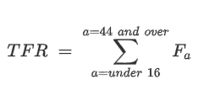

TFRs at geographies below national level are given by:

